1. Open your Opera browser and press Menu button in the top left part of the screen.
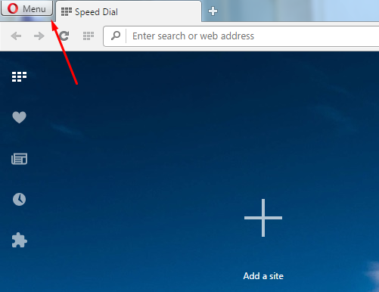
2. Please choose Settings option.
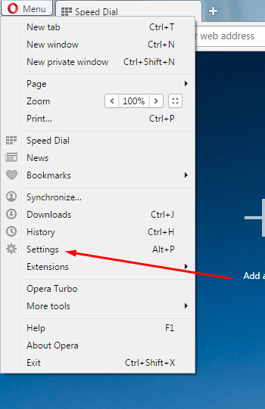

3. In the Settings menu, click on Browser tab.
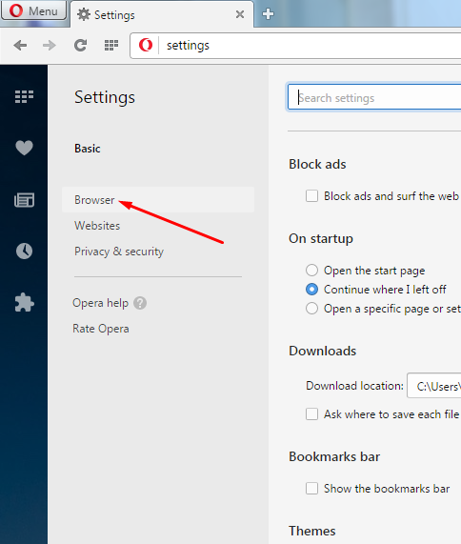

4. Press Dictionaries button in a menu that appears.
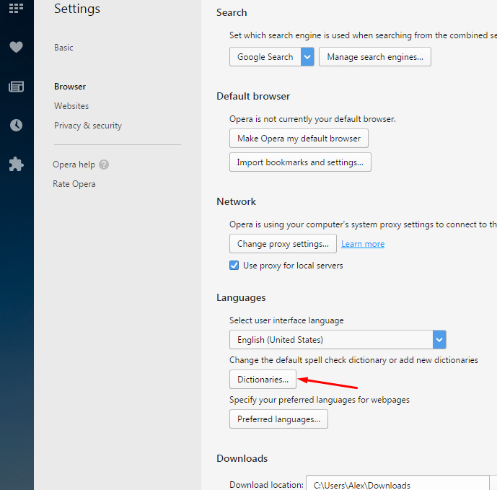
5. Follow next steps to enable spell checking
1. Select English in languages tab.
2. Select Enable spell checking at the bottom of window.
3. Select Use this language for spell checking option in the right part of the window.
4. Press Done button.
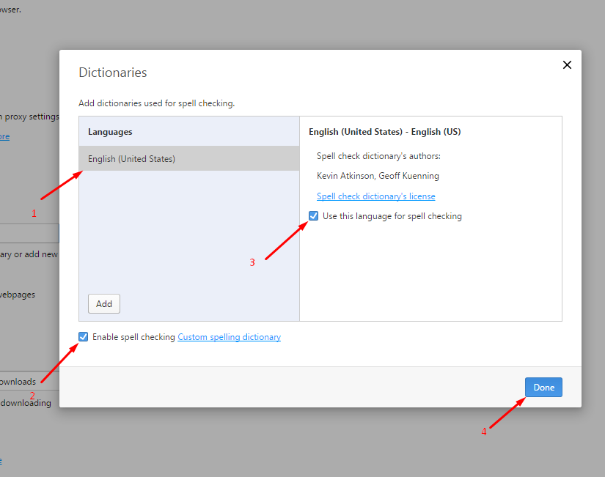

6. If, occasionally, there is no English in the list of languages, you’ll have to add it manually.
In Dictionaries window, press Add button.
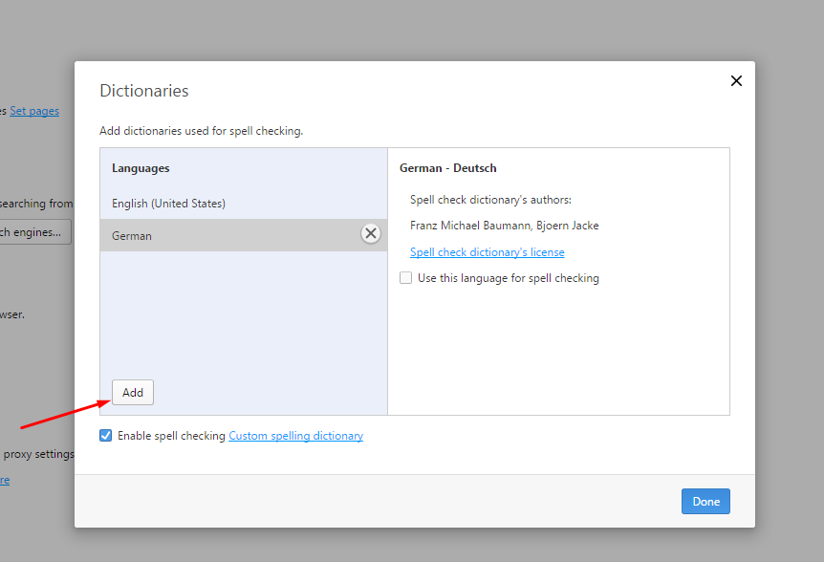
7. In the window that appears, please choose language from the list.
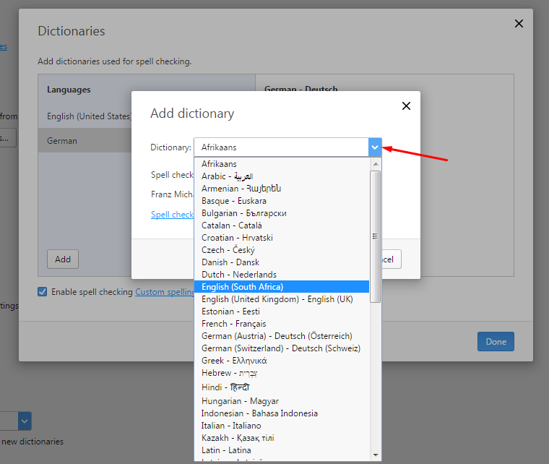
8. If you’ve chosen language you require, press Add button.

9. Select Use this language for spell checking and press Done button.
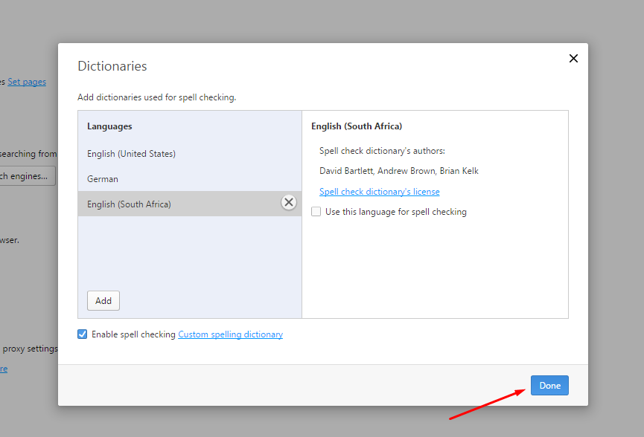
10. As a result, misspelled words will be underlined with a red line. By clicking with a right mouse button on the misspelled word, you can choose an option of proper spelling.
