1. Open your Firefox browser and press Menu button
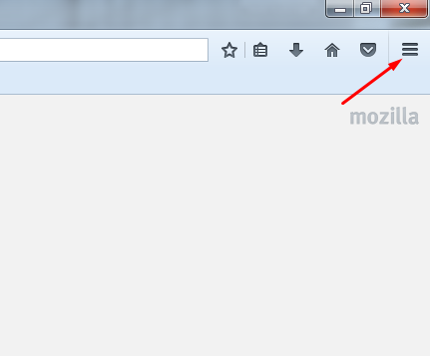
2. Press Options button
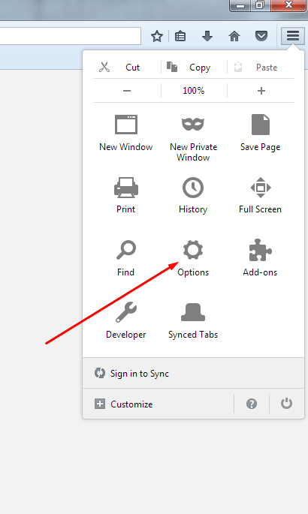
3. In Options menu, choose Advanced tab
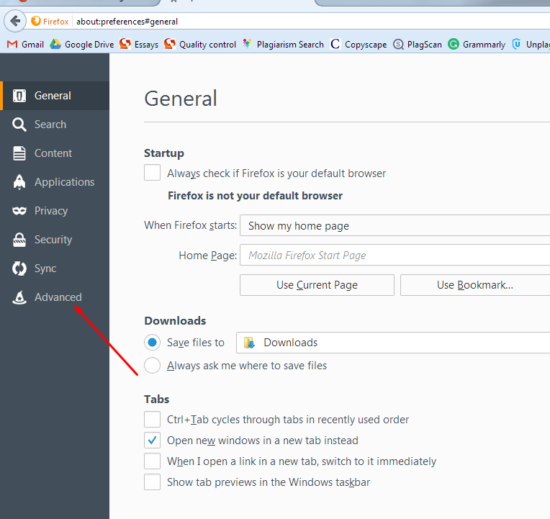

4. In Advanced tab, please tick Check my spelling as I type option
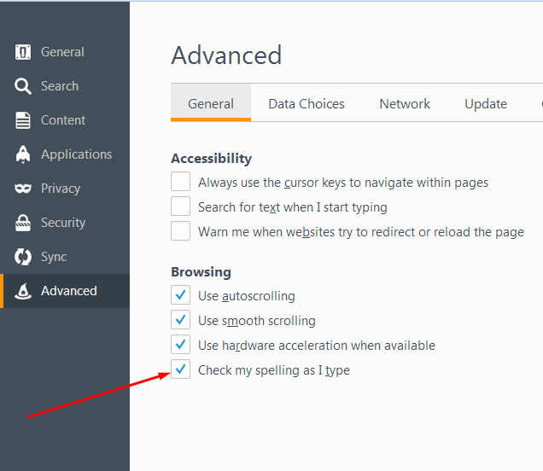

5. To enable spell checking, make sure that English dictionary is on.
a. Open your messenger window or email and click on text using right mouse button.
b. Please choose Languages option
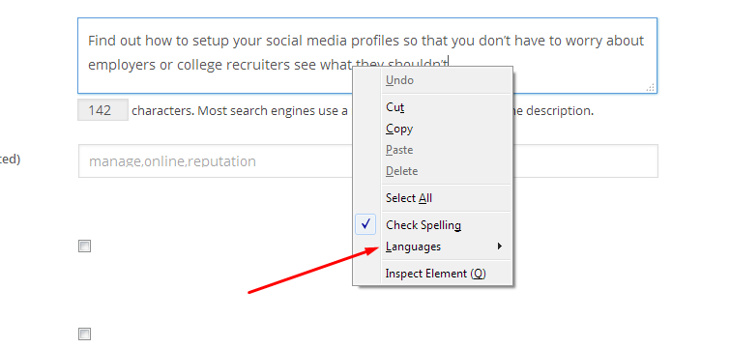
6. In the sub-menu you see, make sure that English language is on
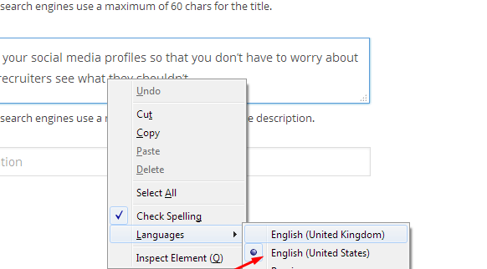

7. In case there is no English dictionary installed, you’ll have to install it manually. Please press Add Dictionaries
8. In the window that will open afterwards, look for English US and follow Install Dictionary link.
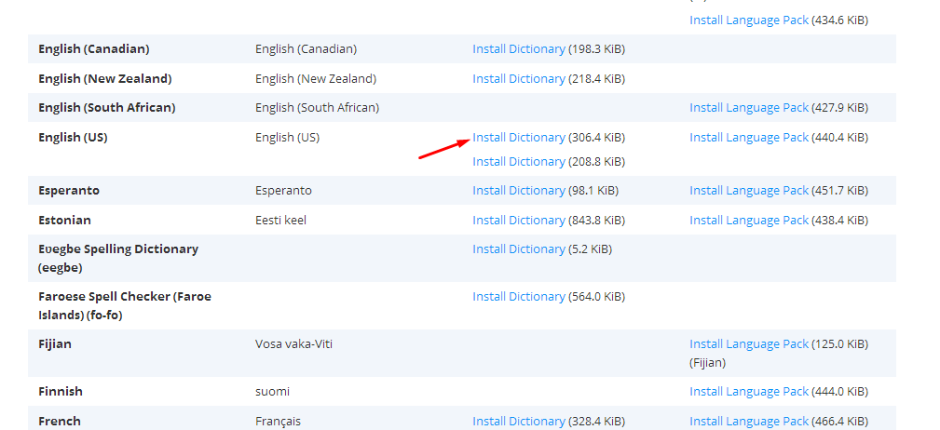
9. In the window that appears, press +Add to Firefox button.
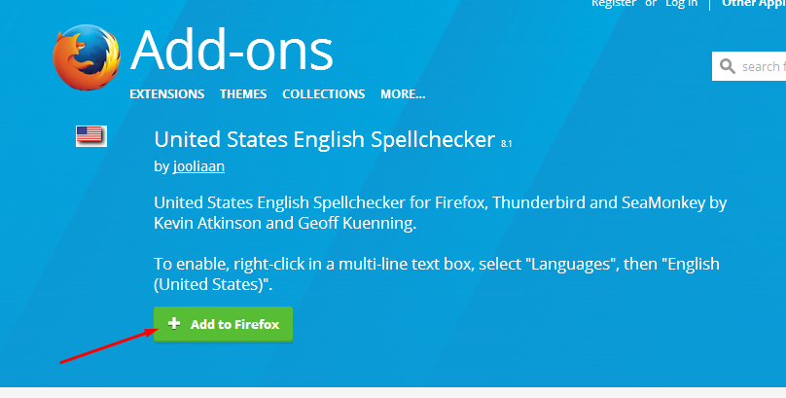
10. In a pop-up window, please press Install button. In a few seconds, the installing procedure will be finished.
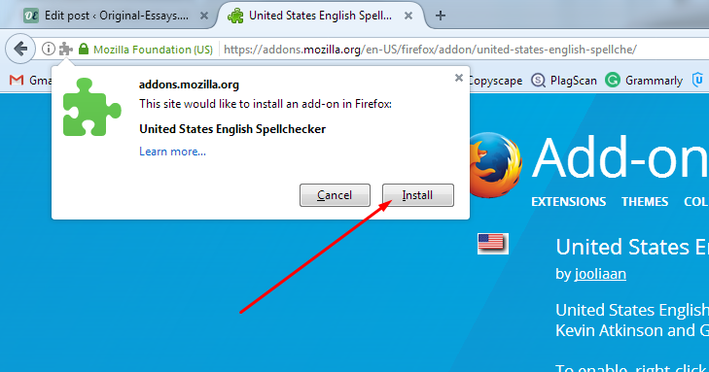
11. Afterwards, turn back to Step 6 of this guide and turn on the language you’ve just installed.
12. As a result, all of your misspelled words will be underlined with red line. You can choose options of word spelling by clicking on the misspelled word with right mouse button.