1. Open your Google Chrome browser and click Menu button in the top right corner.
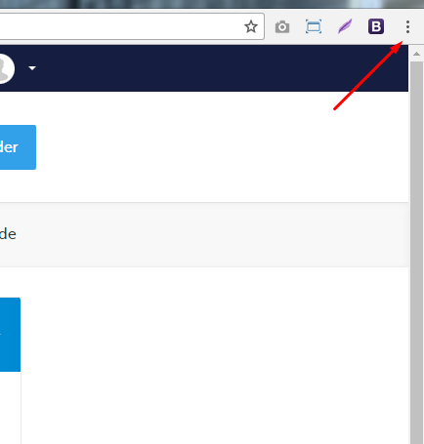
2. Please click Settings option
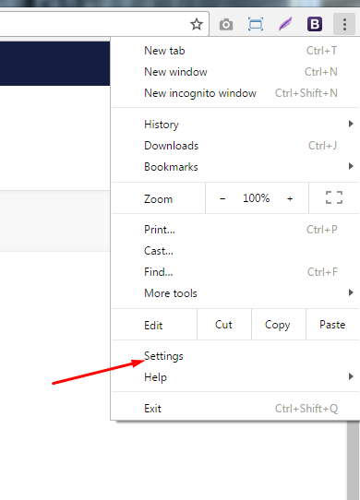
3. Now you are in a Settings menu. Please click Show advanced settings link at the bottom of the page. 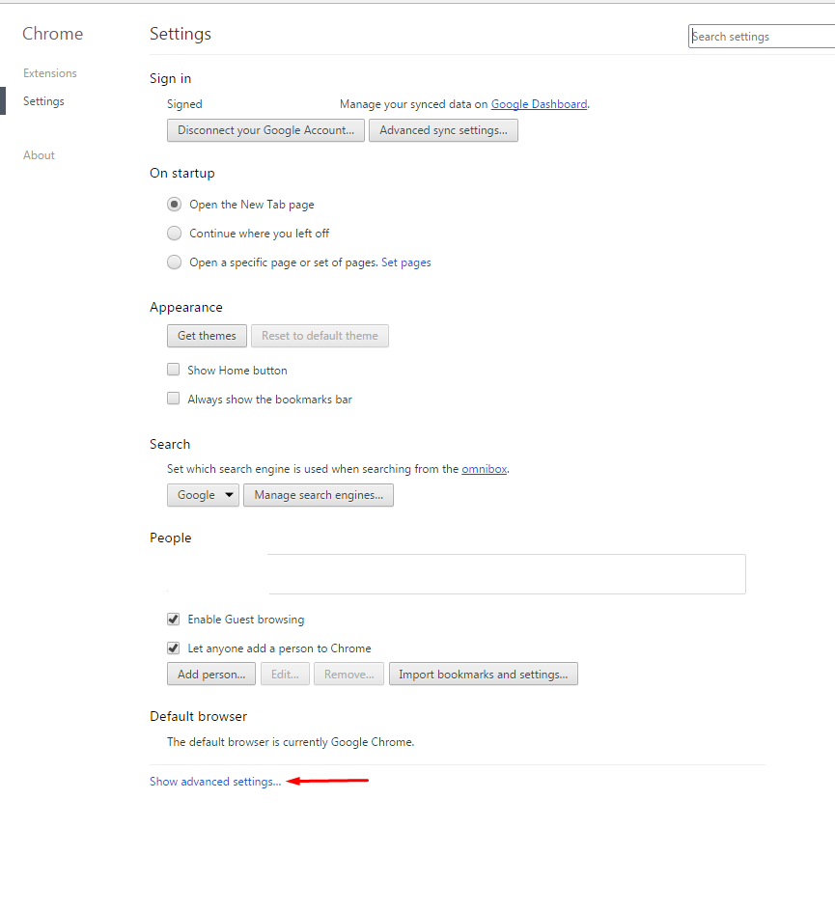

4. Scroll the page down until you see Language and input settings button. Click the button.
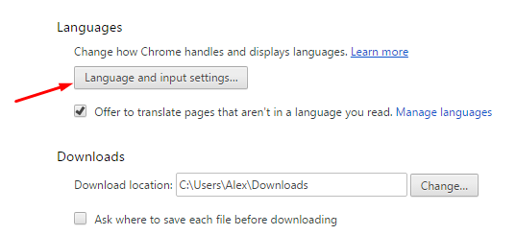

5. In languages menu, take a few steps:
1. Make sure that English language is chosen.
2. Select an option Enable spell checking.
3. Select an option Use this language for spell checking in the right part of window.
4. Click Done button.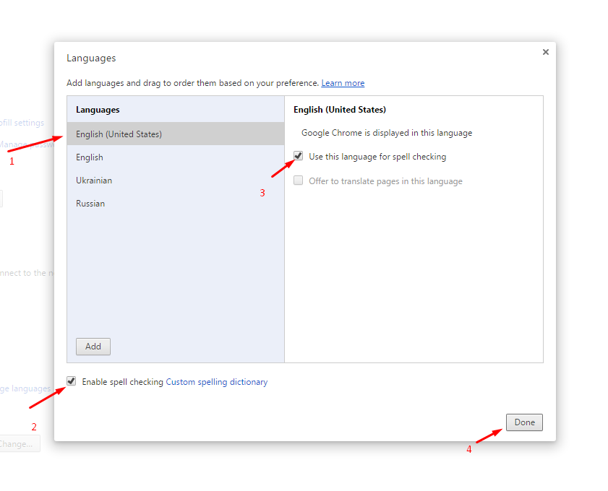
6. Please close all of the tabs and restart your browser for all changes to be applied properly.
7. As a result, misspelled words will be underlined with red line. By clicking with a right mouse button on the misspelled word, you can choose an option of proper spelling.
